|  |  |
| --- | --- |
| Ex. No. 3 | **Design and Implementation of Shop Application with Custom List View** |
| **Date of Exercise** |  |

**Aim**

To write a Kotlin program to implement CRUD operations using SQLite in Android.

**Program**

**Activity Code**

import android.content.Intent  
import android.os.Bundle  
import android.view.View  
import android.widget.ListView  
import android.widget.Toast  
import androidx.appcompat.app.AppCompatActivity  
class MainActivity : AppCompatActivity() {  
 private lateinit var bookListView: ListView  
 private val cart = *mutableListOf*<Book>()  
 override fun onCreate(savedInstanceState: Bundle?) {  
 super.onCreate(savedInstanceState)  
 setContentView(R.layout.*activity_main*)  
 bookListView = findViewById(R.id.*bookListView*)  
 val books = *listOf*(  
 Book("Fiction Book 1", "Delwin", 9.99, R.drawable.*cover1*),  
 Book("Non-Fiction Book 2", "Sharoan", 12.99, R.drawable.*cover2*),  
 Book("Academic Book 3", "Rhenius", 15.99, R.drawable.*cover3*),  
 Book("Fiction Book 4", "Jones", 8.99, R.drawable.*cover4*),  
 Book("Non-Fiction Book 5", "Micheal", 10.99, R.drawable.*cover5*),  
 Book("Academic Book 6", "Felix", 20.00, R.drawable.*cover6*),  
 Book("Fiction Book 7", "Bewin", 11.99, R.drawable.*cover7*),  
 Book("Non-Fiction Book 8", "John", 14.99, R.drawable.*cover8*),  
 Book("Academic Book 9", "Author I", 18.50, R.drawable.*cover9*),  
 Book("Fiction Book 10", "Author J", 7.99, R.drawable.*cover10*))  
 val bookAdapter = BookAdapter(books) **{** book **->** addToCart(book)  
 **}** bookListView.*adapter* = bookAdapter  
 }  
 private fun addToCart(book: Book) {  
 cart.add(book)  
 Toast.makeText(this, "${book.title} added to cart", Toast.*LENGTH_SHORT*).show()  
 }  
 fun viewCart(view: View) {  
 val intent = Intent(this, CartActivity::class.*java*)  
 intent.putParcelableArrayListExtra("cartItems", ArrayList(cart))  
 startActivity(intent)  
 }  
}

**Book Code**

import android.os.Parcel  
import android.os.Parcelable  
data class Book(  
 val title: String,  
 val author: String,  
 val price: Double,  
 val cover: Int  
) : Parcelable {  
 constructor(parcel: Parcel) : this(  
 parcel.readString() ?: "",  
 parcel.readString() ?: "",  
 parcel.readDouble(),  
 parcel.readInt())  
 override fun writeToParcel(parcel: Parcel, flags: Int) {  
 parcel.writeString(title)  
 parcel.writeString(author)  
 parcel.writeDouble(price)  
 parcel.writeInt(cover)  
 }  
 override fun describeContents(): Int = 0  
 companion object CREATOR : Parcelable.Creator<Book> {  
 override fun createFromParcel(parcel: Parcel): Book = Book(parcel)  
 override fun newArray(size: Int): Array<Book?> = *arrayOfNulls*(size)  
 }  
}

**Book Adapter code**

import android.view.LayoutInflater  
import android.view.View  
import android.view.ViewGroup  
import android.widget.BaseAdapter  
import android.widget.Button  
import android.widget.ImageView  
import android.widget.TextView  
class BookAdapter(  
 private val bookList: List<Book>,  
 private val addToCart: (Book) -> Unit  
) : BaseAdapter() {  
 override fun getCount(): Int = bookList.size  
 override fun getItem(position: Int): Any = bookList[position]  
 override fun getItemId(position: Int): Long = position.toLong()  
 override fun getView(position: Int, convertView: View?, parent: ViewGroup?): View {  
 val view = convertView ?: LayoutInflater.from(parent?.*context*)  
 .inflate(R.layout.*book_item*, parent, false)  
  
 val book = bookList[position]  
 view.findViewById<TextView>(R.id.*bookTitle*).*text* = book.title  
 view.findViewById<TextView>(R.id.*bookAuthor*).*text* = book.author  
 view.findViewById<TextView>(R.id.*bookPrice*).*text* = "$${book.price}"  
 view.findViewById<ImageView>(R.id.*bookCover*).setImageResource(book.cover)  
  
 view.findViewById<Button>(R.id.*addToCartButton*).setOnClickListener **{** addToCart(book)  
 **}** return view  
 }  
}

**Cart Activity Code**

import android.os.Bundle  
import android.widget.ListView  
import android.widget.TextView  
import androidx.appcompat.app.AppCompatActivity

class CartActivity : AppCompatActivity() {  
 private lateinit var cartListView: ListView  
 private lateinit var totalPriceTextView: TextView  
 private lateinit var cartAdapter: BookAdapter  
 private var cartItems: List<Book> = *emptyList*()  
 override fun onCreate(savedInstanceState: Bundle?) {  
 super.onCreate(savedInstanceState)  
 setContentView(R.layout.*activity_cart*)  
 cartListView = findViewById(R.id.*cartListView*)  
 totalPriceTextView = findViewById(R.id.*totalPrice*)  
 cartItems = *intent*.getParcelableArrayListExtra("cartItems") ?: *emptyList*()  
 cartAdapter = BookAdapter(cartItems) **{}** cartListView.*adapter* = cartAdapter  
 val totalPrice = cartItems.*sumOf* **{ it**.price **}** totalPriceTextView.*text* = "Total: $${String.*format*("%.2f", totalPrice)}"  
 }  
}

**Activity XML Code:**

<?xml version="1.0" encoding="utf-8"?>  
<LinearLayout xmlns:android="http://schemas.android.com/apk/res/android"  
 android:layout_width="match_parent"  
 android:layout_height="match_parent"  
 android:orientation="vertical">  
 <TextView  
 android:id="@+id/title"  
 android:layout_width="match_parent"  
 android:layout_height="wrap_content"  
 android:text="Available Books"  
 android:textSize="24sp"  
 android:padding="16dp"  
 android:textAlignment="center"/>  
 <ListView  
 android:id="@+id/bookListView"  
 android:layout_width="match_parent"  
 android:layout_height="0dp"  
 android:layout_weight="1"/>  
 <Button  
 android:id="@+id/viewCartButton"  
 android:layout_width="wrap_content"  
 android:layout_height="wrap_content"  
 android:text="View Cart"  
 android:onClick="viewCart"  
 android:layout_gravity="center_horizontal"  
 android:layout_margin="16dp"/>  
</LinearLayout>

**Cart Activity xml**

<?xml version="1.0" encoding="utf-8"?>  
<LinearLayout xmlns:android="http://schemas.android.com/apk/res/android"  
 android:layout_width="match_parent"  
 android:layout_height="match_parent"  
 android:orientation="vertical">  
 <TextView  
 android:id="@+id/cartTitle"  
 android:layout_width="match_parent"  
 android:layout_height="wrap_content"  
 android:text="Shopping Cart"  
 android:textSize="24sp"  
 android:padding="16dp"  
 android:textAlignment="center"/>  
 <ListView  
 android:id="@+id/cartListView"  
 android:layout_width="match_parent"  
 android:layout_height="0dp"  
 android:layout_weight="1"/>  
 <TextView  
 android:id="@+id/totalPrice"  
 android:layout_width="match_parent"  
 android:layout_height="wrap_content"  
 android:text="Total: $0.00"  
 android:textSize="18sp"  
 android:padding="16dp"  
 android:textAlignment="center"/>  
</LinearLayout>

**Output Screenshots**

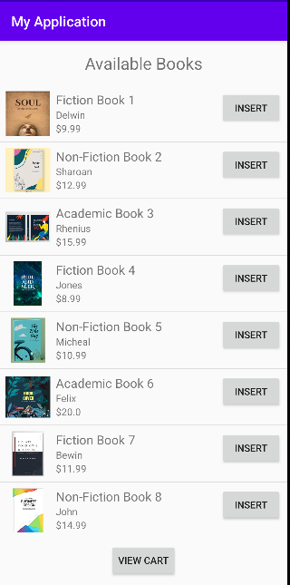

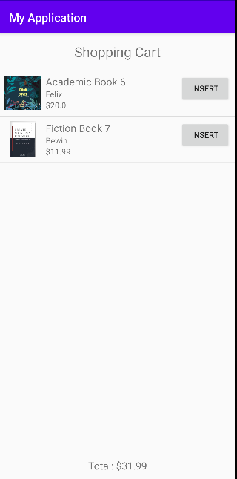

**Result**

Thus the code is executed successfully and the output is displayed in the console window.